^{[2 so} Monday
HEMICAK BONDING.
BOND, Attaction eu atoms or molecules
2: Covalent
3: Metallic
A: Opinionate
’Qantem o.s.
-L shol
M= 3 - M she0
)
n= 2
,orcogy
Sulbensgy
-Qovels
g;k,h M,N
M=3
b-0,l,2 SiPd le o),2, 3 - SPd, f
Magretic
mo
Emphatically
Cony one
orserta)
Connection
onbitals en a sabs hell.
m2,-,o,,2
m--3,2,I,0, l,2,3
An bl,, at eS
alone he aes
^{the} ^{correct}
^{S}
^{n=3}
m
^{etl}
^{Tuesday.}
^{the} ^{correct set} ^{e} ^{quantum nos}
m
⁼⁰
³⁰
^{Q}
^{palo195}
+
h
₋
^{cl}o
^{c}h
w
^{ise}
# ^{Spin} ^{QN ’}S
’ ^{spinning,}
^{il} ^{the}
d
⁻o
b
^{itals}
^{have} ^{Same}
^{encigg}
^{X}
^{Coalmont kind}
^{Jhen tuo}
^{knengetics}
^{hlecthescday}
^{es}
^{paing} ^{noill tahe} ^{place only}
^{Hunds} ^{Kuale Of} ^{Maimum}
^{mo tuw0}
^{Pauli's} ^{Conclusion} ^{Principle}
^{uh}
^{acceding}
^{fiom the following}
’
^{AafbauPoiniple.}
^{met Sammy=0}
^{8- 2p²}
^{lctoon. aloins} ^{onoial.}
^{9: 3P}
^{hey} ^{arc}
^{degenerate.}
^{Q:} _{While no} ^{possible}
^{Hyaoqen caloS} ^{ano}
^{O Chen' cal}
^{Bonding}
^{whom all} ^{he}
^{Multipiatt}
^{S=%}
^{bitals}
^{s}
^{n} ^{ann}
^{atom}
^{can}
^{ave}
^{SAme}
^{set} ^{of all} ^{four} ^{quantu}m
^{m+2) naue} ^{Same} ^{to}
^{some}
^{easo)}
^{the} ^{Gne uth} ^{locoest}
^{to}
^{her}
^{me)} ^{Nalue}
^{are tied} ^{in the capital}
^{n} ^{he énCAaing ada}
^{enegu}
^{m=-)}
^{n=} ³
^{3. |5te}
^{quontum} ^{no. nalees}
^{au}
^{n}
^{m=0}
^{n=2}
^{n-2}
PRT
BDE
Anharmonic Oscillatus.
BDE Ctve)
EA (-ve)
cl c
Theovéital dagnam
parental graph
Flectron Ainuty
beneath l mole of a pound
foy hamoe osci(atos Ctheorelial ) the moleaule an be
dmnd c ^{ensngy} _{eleared} when ^{an}
conpresed and &iretchecl to maimum un thau bond dnhanone oscillatos donot Stretch
Nalenee shell o,
iolated
gaseow atom.
that murh and uill b2eata bondi t fehct
Bond Rigodatlan
Na + c
u C-ve)
NaCl -ve
Ionie Bording The
acompanecd by daase 4eioqg.
_{katiee} krnag _{Cu)} CAlaays neleese when
|mole a
SoWd ionic mpo
Ome alom completelsy kos e Cation
and othon gaun an a anion
fomed gorm
geseous
Na Cles)
clectrotical ^{anteaction coich eourt b}
Nas)
Ctve)
Constituon
bond.
_{Knugoties} oic _{Cond} omation
EA C-ve) c9)
Na
g)
Anthalpy _{ic7} fonmatuon Ca, t)
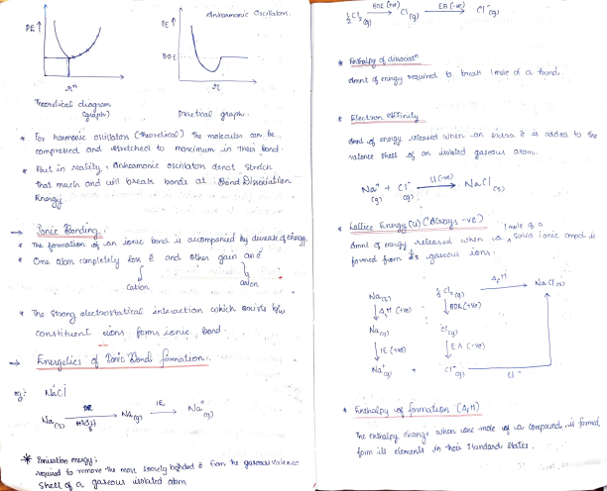
The endhalny ehong
Tonisation energg
Aquasd to remove tha _{most} loosety bohded è (om 'he garesy Valenco
Shee a ^{gase0US wsdlated} abm
whan _{cone mole} a ^{Comypound s fomd}
Bomtaber Cyle
sed to find Lattite Rniralpy. undiectly uimy tesss kacs, tHess's Loaw
M9c)
s
place in
miLtiple tepi
Mg c9)
Mg 9) ⁺
2f ca)
2
13 J
2332
3
G76
4
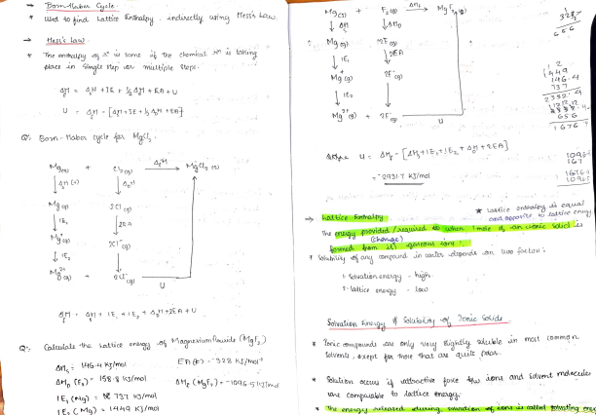Q: Bon-tlabea cycle ao Mgl,
cs)
9431-7 KT/mol
hot tlce Gthaly.
1616-4
Latice ^{endhalpy} s ^{eaual} cund ^{opponte,} to ^{lattice} ergy.
ncl ca)
24
The enaau _{provided} /eawred 9 when ^{mole} an uonic soid s Chage)
1 Solaiity e any compound un waler depencis en teso factos
cg)
: Solvaton enegy 2: lattice enegy
Solvation fneg
hig
Donic Soids
Callate the kattice onorg o, ^{Magnerium tlaaide (MMa f,)} En ) 328 KJ/Mo
I46-4 KJmol
AH, (Mgfa)= -10465KTtmol
* bruc ®mpounds Aie snlg vey sightly suleuble n most (ommon Solvent, onept gor hose hat
^{Solution} ocuy ^{atisactive} _{fote} gw. aon ^{and Solvent molecles}
IE, (Ng) E 137 ^{KJ/mo}
ane
Compaalble to dattuce eneng
Mhe enen neleased duin solucation eons cis callo sotvotin enx
^{Ovealapping heud} ^{be done wit} ^{Sameirn.}
^{ehnges}
^{P} ^{subshell}
^{proposed} ^{ky inus} ^{Pauling}
^{S} ^{Subhell}
^{tCmbimirg atomd.}
^{The partial} ^{interpeneination}
^{bond fomed}
^{Valence} ^{Bond TheOy}
^{fomed ay} ^{he shaaing}
^{CovALENT}
^{OVeLOmes attice} ^{energy}
^{an}
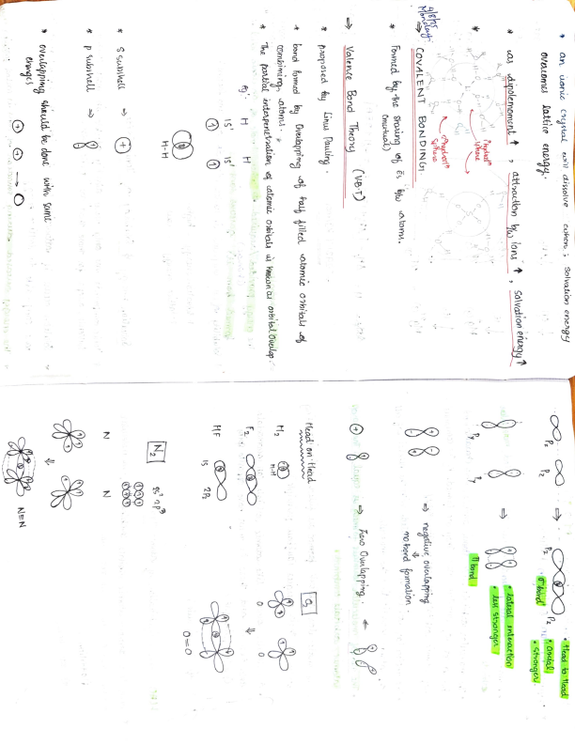
^{H-H}
^{H}
^{calomi}
^{osbilaly}
^{knocuon u} ^{orbital} ^{Ouelap} .
^{N}
^{P}
^{2P2}
^{Gty Ovealapring oß} ^{raly illec}
^{otomec othitald} ^{oh}
^{ead on tlead}
^{Cmutual)}
^{(vBT)}
^{s}
^{to iatom.}
^{BoN} ^{DING1}
^{dAhydrert"}
⁸⁸

^{Phydat"}
^{dinolemoment}
^{t}
^{Solvation} ^{enwzgy 1}
^{uone Cystal}
^{will dissolve}
^{Cuhon.}
^{Solvation ener&9}
^{NEN}
O
⁼⁰
^{Aono Ovelappingo}
^{mo rord} ^{fomaion}
^{tead} ^{to tead}
^{nugalive ovelagping}
^{kateral} ^{AnleactoO}
^{bond'}
^{Gtronge.}
’Moleceular Orpital, Iheory
M0-T)
TMO
inling an e
* ^{propasecd} ky ^{fiurd} $ ^{Auttie . Malliten}
+ lowea enegy ^{Mofomec.}
protaloiGny
un w specic region aasund
n ^{molecules} , ^{és} ae ^{prsent}
un ^{mau orbitaly} aalled ^{mole} culas
* favouss bonding
Bordirg Miletuloa Osloial.
The ^{molecular} _{ebitau} , ^{lke atbmic} _{ozta,} ae ^{Ohasaieure} obital
_{They cue fomed} ay same, eng
the comainaton
MO
he ^{melotulas wibital,} çe
iayociatad witn _{he} neclei os al
* ftiqher enegg han ^{corminerq alotala}
_{the} atoms ^{uonstituting} tho ^{molecule.}
. _{The} moC ^{mocula} _{bbitals fomed} s ^{equal to the Moo} atoe bitals comoined
. _{The} maleculan alitals fames ae filled .an _{Tha,} ancreaing ^{thes} enDgus Canfoau. paincle)
" A moleuleu ootal , Rike otomir bitala, _{Con} cacOModale too s and these s must hae cpposite gpins Cpauli's prineiple)
* _{Opposes} bond fomat
8
+
Antibording,olecatax Onkitls 8-8
Ois
Tuday
when uso aitas, atomic oxtotata comalne to fom noleculas hitl, thy con do so n two
Daddtion
) Subtnation.
Moleculca Ornital Conjiquaion.
Bond Ode.
_{kond} prcsent an _{Guo} ^{atom} un the molecule.
Ond StabUty
Bo =
ho molecle. i3 oel
Nanooh es un ^{ABMo(Boued)}
B.0 diactly fropootional to Bonch dissociatn
enougy
Bord kong th iveuly popotional .
2
25
Molecula Osbital iagnar.
O6los|25
Madnaday
Nh 10
25
M0
H-H N,
2
t46 s2
³ 2s 2P.each 2
2p
25
2
M:0:
Na,:
F-F
each 2
2
2
15
IS
Na4
B.0 = Co-4) 3
HereRO ^{NUCLE} AR ^{MOLECULE}
11
2
25
CO
Bo 0-4) '
09-08-2025
2
2
2
2
(Bo-33
C=o
Oouyge
Tida ’ Fajons Rule.
onplainy the tovasnt paatil covalont chmaete oh onue cond. dapend aâpen
when we howe tuso diff atoms , tha atomc onbita) level
p0lniting powo a Calion.
claetoonagatuwe atom acit be ghtiy the othr.
Cenngy
Cocwe than
anuon.
Coon. The _{gn} polaaisi ng powa as _{catiön} deeneases.
Govpone the Bond dinodation ensrgg N,, N,T
polarnng owen
2
2
2
2
2
* doun he ge palaacsabilua anien àAcONI.
F -
-0 a"!
Covalet nae
AiCI < 6IClg
Smallu ine Siye oi ca ion age he chaQe of ation
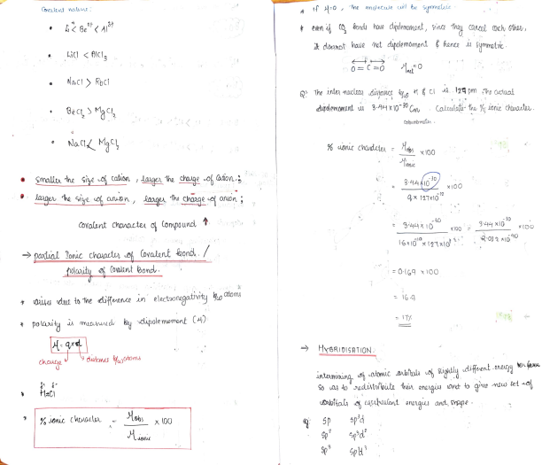
lhe molecuwe cul be symmelte
Q' The ania muclean distance tae 6 CI .124 pm ho actaal Colbunbmaun .
% ^{uonic} chaudeten = lobs xIO0
g-4410
lage he siye oh anon
Choge o onuon
CoValant Chcnacter o Compound T
’ patial Tonic chaat, oh ovalent kond. / Dde due to 1Ihe difuence n _{electaonegativity} ho toms
x\0o
i
=0lG9 x 100
x LOO
032 AIÓ10
poloity
s mecwnd by apole mument CH)
H-qrd
% Jonic cheacle
A
x \00
HyeRIDISATION.
Doita eautalant energes and, Snape
qend frcitei B
2
BF3
dnean
180
c
sp'a
E-S -
|spa
35
pcls
sp'd
3P.
aioqoral apyanaidal
C P
.? = 120
252
C
Es -
2p
"ogpnal ilava 2p
2P
H
2p
S - 36 38
552
3P
5 p5
Spds
Octahedral
pentaqonal aypgamidal
F
aneahalaen ornpounds
teloahedal
_{Valente} Shell ^{klectnon} Pais ^{KepulsIOn}
Theo v ^{(VSEPR)}
_{*,Sidquwg} § ^{powell} _{kued} or ^{upulive ateraetions} o ^{¬pais}
_{lo-} tp > p- ^{Bp} > ^{Bp-Bp.} '6ncla
uh ^{Valenco} shele os ^{atoma} Sn
G15 -
bee scu) shape
Berd angle
len thad 120
Bent Shape.
/
C 3
_{due} to ^{ip-Bp epulion}
N- gs ^{ep?}
sp
Lnteted cumbadla.
Bond
Pyamidal
N
I- 55
⁵ 5p
sp'd
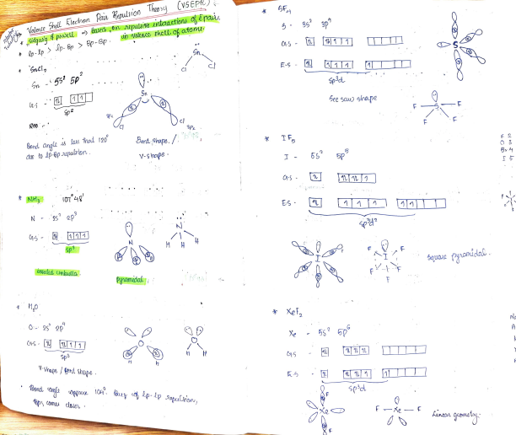squaie yanidali.
Xe
te
Mondalç
-
Xe
Metallic taonds
mopeties of metaly
2. luwtre
Neuy ^{loaw cionsation} enog
Bord. panh
pai
Fnample.
^{*naiou} heoej-nlle beer, _{ppoposed} ^{to} aclon ^{oy he} natne e ^{hsndin}Un4.dn, mital,
^{The} Clasical .he _{Eletogn heong}
poposed ey Bude and horentz.
2 2
Ainias
Bent
Bent
linca
BoCl,
Ldea. based : Cove
hign' elecical and Ahma conductivities ch meta aue
Spd
sp'd.
iagenal lanca. Pyamidal T-shape.
teahedna
bee-seu
Saquane plno
Nhg
CIf,
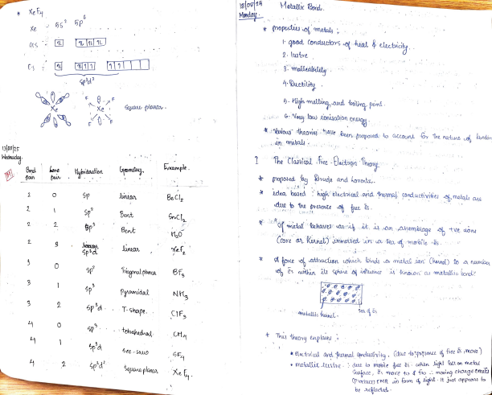
A foxe o, «attaacisn ushich loindy o metal ian Chencl) to a numley
Ametallic heine
* ^{This} heony _{eauplauns}
* electolal ard hemal Conclucivity. (due to 'pesone the s jmove ) " metallic eeste. : duc to mobile nce as: when igh! fall on metal Suface, more to f foo . moving chauge emits
(Pecluco) EMR un fom ught t just appeay fo
be acflcded
maleabty ducility : Since metati c tond 4 non diochionf
tligh tensile stoength : on ait stretching
cuihout brecaking
due to ^{Stong electostatie foxe o,} Latthaction.
s calitcd Seconday
hald
aond fonte,
togelheu
"Rlas ticity ' movermcnl o melal 4on.
binuta fign - coutdnt onplain aatative ditecuct in cekun 2mnial _{prpehe.} The Nalene Bond Thuong
davdiped ky pauling
postulaty that
irtemoleculay koxes one kroron a Van de Wals fotet
-Ton dipole irtenctioru.
ci,esponuiblé fov the sövation, a icns y polan soivent) iand distolktror o ionie subrtancey un such olvents.
Kesrance pumits the enistene ioh
"momal covolenuey hich
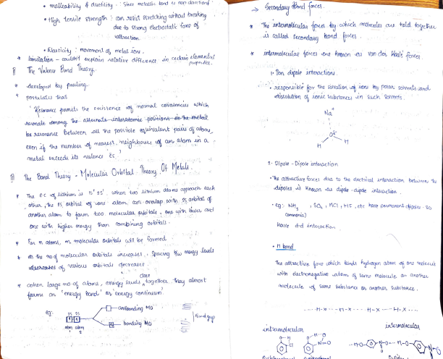
the aterete _{untertomte} poa4tonsde ht netal
_{ke} aonane between all he possible _{ea} uinalnt pas ah aby an adom n o
metal ^{eAceedu itt valenca es}
The e-c o lithium s Is´ 2s. when _{tuso} itnlum ^{atomu} appoach lach other ,he 2s oibi tal e on _{Odom,} onovelap with 5, 0ortal anothr atom to fon tc0o. ^{moleculas} ahifals, ono cuin locwe avd
Na
2-Dipole -Diçole inteucction
"he attoacire foxes due to the electical interaction betweenu he dupdle -dipole intecisn
, SO, , nCI , HF, ete have pemanent ipoleu -So
Comvmonia)
than ombinung oroials
loa n _{atomy,} mglecular uaials csl lbe foYmed
nave
d-d inteoction
ds the _{no-o} moleculn abias uncucases, Spacg w enongy vanlous abites decreases.
he attactive foxe cohich kincs hydusen
atom of one molecule
doje
cohen laqe mo-of aloms, eneiqy ^{lewestogelher, ey almost}
itn eiectronzqatie atom Oh Samo moleule e another Molecele c Same sebstance angther Subs tance.
an
engy barcu' a enugy contiouum.
2S 25
abm atom
Fanitonding Mo' bondng Mo
ntamaleculan
H-0-- H-*---t-x H-X indemolecula,
hepora deu'vative.
undeugo ^{asiodation} ,AMuting
Palaxity ^{an} mon-polar dodane ^{CI,)} molecule ’ Flect0mei eeect
may cand hence an ncecue un boiung point
* Otho ^{deunatwes asG mse volatile} than ara dei vatineg
4 dipole Ancluced dipole ineaction
ono nitoo phenst ,volate, an pteam lp-nitophenol,- nony atolatile an Steam
.Gtean di's Hilbto
dipole znducinq Tuaity n a no ^{pola} malsculel
. he octing pointo o NMS, M,0, Hf au abnomaly hgh ue to ^{Shong} ntemolecutan
nple anOiatlon to the molele . no. bónds O . hageaated enon compouná
onhuing
5 nduced dipole - nduced cipole inteaction
9 ^{Why} uce _{Qess danses} han ^{water}
London foxe
o Van deu waals toxe.
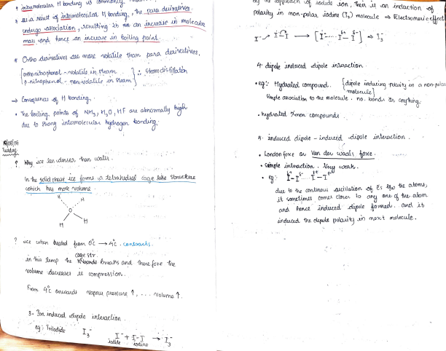
In the solid phasé 4ce om a detahecal iane uke Stauetue ohich hay moe volume
COge str.
un his lemp ^{he} Noondbreahs ^{and} thenefore tre ^{Nolume} docncases ^{e} (ompresion.
" Cémple intuadion weak.
due to _{the} continouy ^{escilation oh Es lu the} atoms it _{sometimes} comes closer ^{to}
and _{hence} incueed cipole fooecu. ane it anduced the cas pslaui ty an ment molecule.
from Ac Onwnd
Napoua pAK Ue
Nolume
3. ^{Dor anduod cipole} inteacion
eq: Toiodd
I _{Jndidey 20dine}

